Blue Nature Alliance
Implementing Partner Interim Progress Report for Sites

Section 1: Project Information

Name and contact for implementing partner: Manuel Amoris Ramiro Matos Maluf, Technical Director of Fondo MARENA (MARENA Fund).
Project title: Caribbean Engagement - Dominican Republic Intervention.
Project start date (month/year): November 11, 2023
Project end date (month/year): June 30, 2024
Section 2: Project Progress

- Briefly describe progress made towards the project opportunity, key interventions, and milestones, including the most notable successes and most difficult challenges to date.

During the reporting period, the technical team has made significant progress, completing 20 out of the 33 planned activities, resulting in a progress rate of approximately 61.0%. Notable key interventions include:

Scientific Expedition to Beata Ridge: Conducted from January 27 to February 14, this expedition aimed to gather data on the diversity and distribution of oceanic species. It was essential for creating the Orlando Jorge Mera Marine Sanctuary. Participants included experts from the Ministry of Environment, Eco-Bahía, Fundación Ecológica Punta Cana, ANAMAR, and the Caribbean Cetacean Society (CCS).

Scientific Expedition to Banco La Plata: This expedition analyzed the biodiversity of the area with participation from the Blue Marine Foundation, Mission Blue, and the Ministry of Environment and Natural Resources. Samples were sent to Nature Matrix for environmental DNA analysis to support MPA expansion.

International Conference OUR OCEANS: Held in Athens, Greece, from April 14 to 18, two delegates from the VMCRM highlighted the Dominican Republic's achievement of protecting 30% of its jurisdictional waters and recent advances in MPAs.

Data Interpretation: eDNA Tool: Environmental DNA data from the Beata Ridge expedition is being analyzed, with a preliminary report in preparation to inform marine biodiversity conservation efforts.

Economic and Social Feasibility Study for the Orlando Jorge Mera Marine Sanctuary: Workshops were held in Barahona, Pedernales, and Santo Domingo on April 4, 5, and 9, respectively, as part of a feasibility study on the social and economic aspects of the proposed protected area.

Decree Signing: On April 11, decrees 194-24 and 195-24 were signed, establishing new protected areas and expanding marine biodiversity protection beyond the 30% goal.

Educational Seminar: On May 2, the VMCRM participated in a seminar to disseminate the results of the decrees and the Beata Ridge expedition, promoting marine conservation awareness.

Workshop on OECMs: On May 22, a workshop was held to identify marine areas meeting IUCN criteria for Other Effective Area-based Conservation Measures (OECMs).

Additional Activities

Formulation of Management Plans: The technical team developed drafts of the terms of reference for management plans for the Marine Mammal Sanctuary Bancos de La Plata and La Navidad, and the Orlando Jorge Mera Marine Sanctuary.

Reformulation of Phase II Activities and Budget: In May and June, the team focused on reformulating project activities to prepare an addendum necessary to access remaining funds for Phase II.

Monitoring, Control, and Surveillance (MCS): Meetings were held on May 22 and June 4 with BNA and WildAid to receive guidance on MCS for remote MPAs.

Marine Corridor Forum: On June 4, Jonathan and Carolina presented the project's current status at the Marine Corridor Forum of the Caribbean Biological Corridor (CBC), discussing strategies and achievements in marine conservation.

Notable Successes
- Scientific Expeditions: Successful completion of the Beata Ridge and Banco La Plata expeditions provided critical data for marine conservation.
- Expansion of Marine Protected Areas: The establishment and expansion of MPAs through signed decrees have significantly advanced marine biodiversity protection.
- International Recognition: Participation in the OUR OCEANS conference highlighted the Dominican Republic's marine conservation achievements on an international platform.

Challenges
- Monitoring and Management of Category 4 MPA: Ensuring effective monitoring and management to maintain the integrity and conservation goals of the Category 4 MPA remains a primary challenge.
- Accessing Phase II Funds: Securing funds from Fondo MARENA has been challenging due to the need to reformulate the entire project to meet new requirements, delaying progress.

- If applicable, describe any changes to the political, social, or environmental context that may impact the project.

Before the signing of the decree on April 11th to establish and extend the country’s MPAs, the initial idea was to classify SMOJM as a Category 2 MPA according to IUCN criteria. However, the day before the event, the Minister of Energy and Mining shared concerns with the President of the Dominican Republic and the Minister of Environment. This unfortunately resulted in a lower safeguarding criterion, and the President signed a decree for a Category 4 MPA instead of the initial Category 2. Despite this, we are ensuring that the Category 4 classification provides adequate and effective protection.

If applicable, describe how you are adapting the project approach to address any challenges or changes in context in order to achieve the project goal? Please specify if these require a change in project scope or budget.

Accessing Phase II funds from Fondo MARENA, which requires presenting an addendum to the Ministry of Planning and Economy. The technical team has reformulated the entire project to align with the new requirements. This includes revising project goals, timelines, and activities to ensure compliance and securing the necessary funds. We have also expanded the project scope to include additional research and conservation activities that align with the ministry’s guidelines.

- Describe any lessons learned that could be relevant to project design, implementation, adaptive management or to the general conservation community.
Early and continuous engagement with all relevant stakeholders is crucial for project success: By involving local communities, government agencies, NGOs, and the private sector from the outset, we gained valuable insights, fostered cooperation, and built a strong support network that has been instrumental in overcoming challenges.
Flexibility in project design and implementation allows for adaptive management in response to unforeseen challenges: The ability to reformulate project plans and activities in response to new requirements, such as those from the Ministry of Planning and Economy, has been vital. This flexibility ensures that the project remains relevant and achievable despite changes in context or unexpected obstacles.
Clear and consistent communication between all project partners and stakeholders is essential for smooth project execution: Regular meetings, updates, and transparent communication channels helped prevent misunderstandings, align goals, and ensure that all parties were informed and on the same page. This coordination was particularly important during the reformulation of the project to meet new funding requirements.
Exchange rates: When budgeting financial aspects of activities, calculating costs at a lower exchange rate ensures that fluctuations do not adversely affect the execution of activities. During the expedition to the Silver Bank, the team initially requested a certain amount based on current exchange rates. However, due to fluctuations, the budget fell short, and additional funds had to be requested. Moving forward, the team will budget conservatively to account for potential exchange rate changes, preventing similar issues in the future.

- Please share any relevant photos, videos, news articles, meeting reports, or other project products. Please give a short description of each photo/video, along with photo credits.

Image | Description
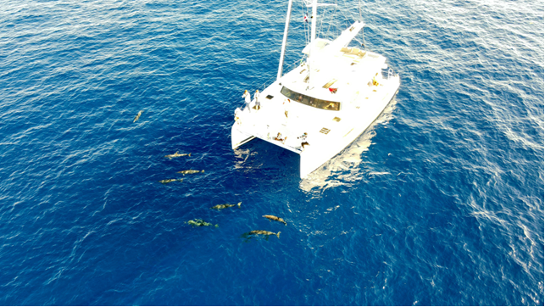 | Scientific expedition to the Beata Ridge, credits to Arthur Callier.
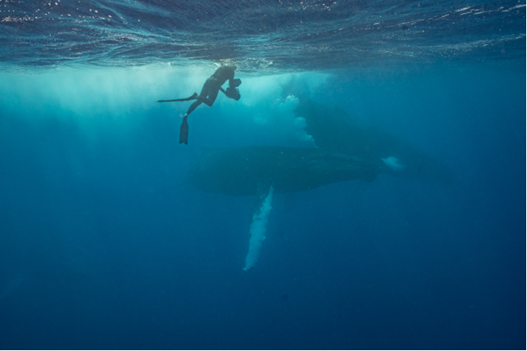 | Silver bank expedition 2024, Credits to Max Bello, Mission Blue.
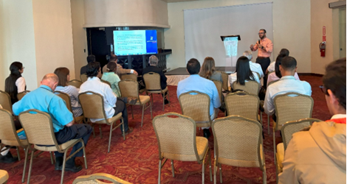 | Jonathan Delance, Coastal and Marine Affairs Advisor, welcoming participants to the workshop held in Santo Domingo on April 9, 2024.
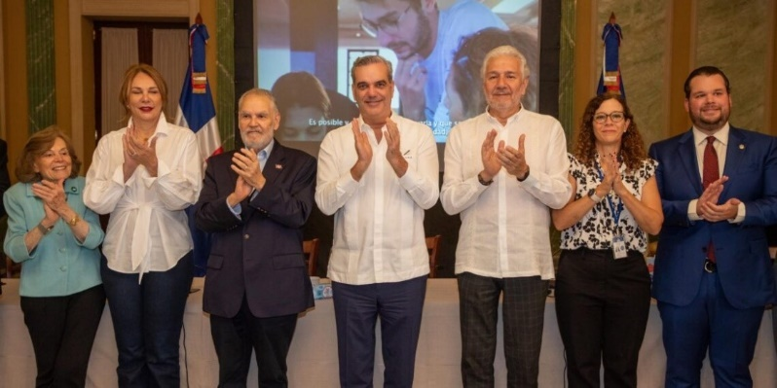 | Signing ceremony of decrees 194-24 and 195-24 to achieve the global goal of 30% protected marine areas at the regional level.
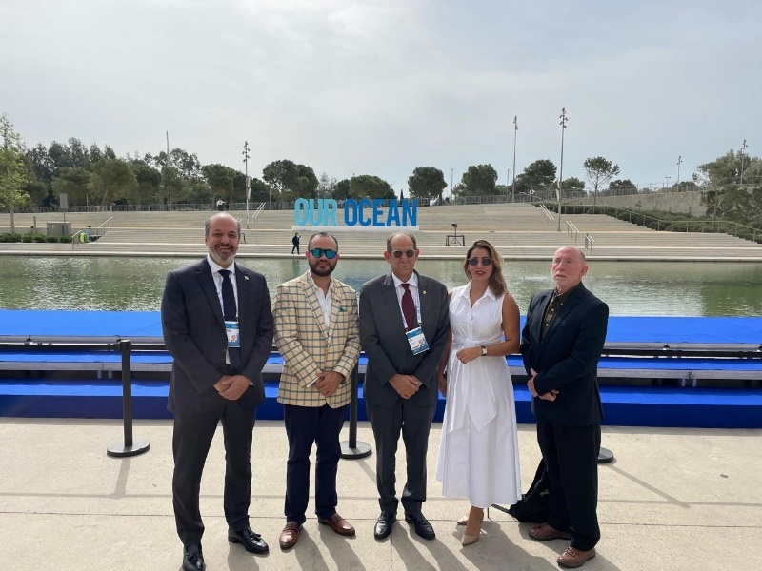 | Delegates representing the Dominican Republic during the event.
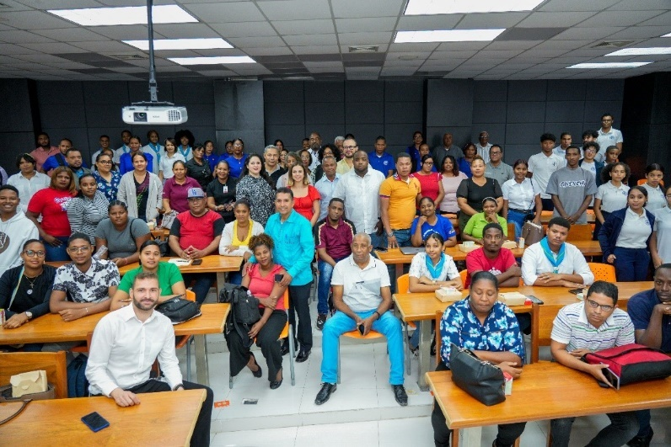 | Participants and presenters of the environmental education seminar.
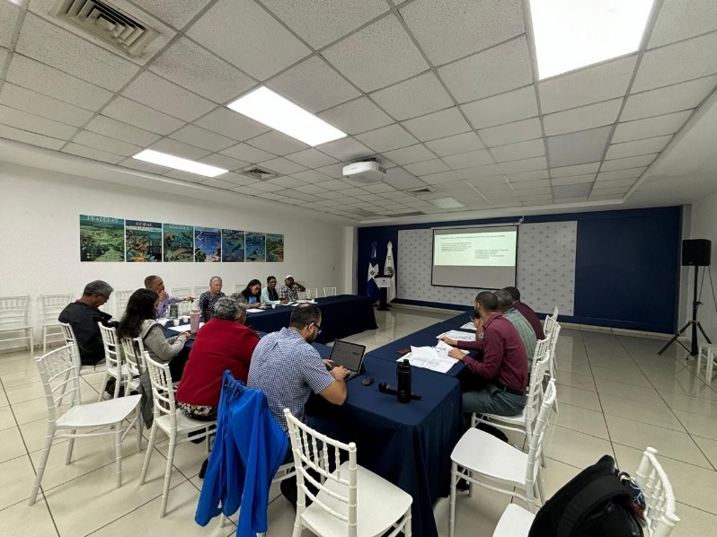 | Internal workshop at the Ministry of Environment and Natural Resources (MMARN) to identify and/or ratify the proposed marine areas for the project.

Documents and minute reports of the meetings are in these links:

- …

Section 3: Safeguard Implementation

- Review the Stakeholder Engagement Plan and Gender Mainstreaming Plan that you completed as a part of the Safeguard Packet that you submitted along with the proposal. Review each plan and complete the column titled “Reporting Update” for each row following the instructions provided in the table and submit to the Alliance along with this report. Alternatively, you may also schedule a one-hour call with the Alliance Safeguard Advisor, Whitney Yadao-Evans (wyadao-evans@conservation.org) to review and discuss the plans and together complete the update column.

- Has the project engaged with new stakeholders that were not previously identified? If the project engaged with new stakeholder groups considered to be Indigenous Peoples, please describe the process of free, prior, and informed consent employed in the project to ensure their equal and just participation.

No, the project has not engaged with new stakeholders that were not previously identified.

- Have you received any grievances to the project’s Accountability and Grievance Mechanism? Do you feel all of your project’s stakeholders are appropriately aware of the grievance mechanism? If not, what do you plan to do to ensure that the Accountability and Grievance Mechanism is well established and accessible to all of the project’s stakeholders?

No, we have not received any grievances to the project’s Accountability and Grievance Mechanism. While many stakeholders are aware of the grievance mechanism, it is possible that not all stakeholders are fully informed about it. To ensure that the Accountability and Grievance Mechanism is well established and accessible to all stakeholders, we plan to implement the following actions:

- Conduct an awareness campaign to inform all stakeholders about the grievance mechanism. This will include creating informational materials such as brochures, posters, and flyers that explain the process in clear and simple terms.
- Distribute these materials during stakeholder meetings, workshops, and events.
- Utilize multiple communication channels to reach a broader audience, including emails, social media, and the project's official website.
- Ensure that the information is available in local languages and is culturally appropriate.
- Provide regular updates on the status and outcomes of grievances received and addressed, ensuring transparency and building trust among stakeholders.

Section 4: Monitoring and Evaluation

- Please report on progress towards the standard Alliance indicators in the Monitoring and Evaluation Indicators Table.

Category | Indicator | Description | Additional Instructions | Response (for this reporting period) |  | Comments
General  Information | 1. Engagement Name | Santuario Marino Orlando Jorge Mera (SMOJM) & Santuario marino de mamiferos Banco de La Plata y la Navidad.
General Information | 2. Site Area Engaged | Total area (in square kilometers) that the Blue Nature Alliance engages with in order to (1) create a new conservation area, (2) expand the size of an existing area, (3) improve the management of an existing area, or (4) upgrade the protections of an existing area. | For areas not yet established, this can be an estimated projection. | - SMJOM 54,795 km2.  - 30,000 km2.  - There was no execution during this period.  - Silver Bank: 33,176 km2
General Information | 3. Site Area - Measure of Success Reached | Total area (in square kilometers) for each Ocean Conservation Area supported by the Alliance engagement that has reached the agreed upon measure of success. | For new designation and expansion, only report the area after legal designation. Also include the Gazettement date when reporting. | - SMJOM 54,795 km2.  - Silver Bank: 33,176 km2
Growing the Field | 4. Publications and related Knowledge Products, Communication Materials and Tools | Number and type of relevant resources ie, including peer-reviewed scientific publications, reports, communication materials and/or tools that advance the field of large-scale ocean conservation. | Please share copies of any products | 37 media publications |  | Documents with the publications will be sent to BNA’s team.
Management | 5. Management Effectiveness score or status | Management effectiveness assessed via a methodology that is appropriate for the site. This could include a standard Management Effectiveness Scorecard such as the World Bank MPA management effectiveness scorecard (Staub & Hatziolos 2004), or the LME Management Effectiveness Scorecard, but it may also include simpler assessment tools as long as they are used consistently within a site across the duration of the project. |  | Na |  | Only applicable once the management plans are in place for both MPAs.
Management | 6. Sustainable financing status | Determination of the sustainable financing status of an Alliance engagement site. Categories include: (0) No sustainable financing plan in place, (1) Sustainable financing plan in place but not implemented, (2) Sustainable financing plan in place and implemented, but with significant gaps, (3)Sustainable financing plan in place and fully implemented with no significant gaps. | Please choose the category that best reflects your sustainable financing status. | NA |  | TBD within the management plan.
Stakeholder Engagement | 7. Number of people (sex disaggregated) that have been involved in project implementation phase | Number of stakeholders that are directly involved in project activities (meetings/workshops/etc.) as well as stakeholders that are involved in and/or interact with the project. For example, this indicator would include community members who attend awareness events or public meetings; individuals who engage with project through surveys or consultations; etc.  SEPTEMBER WORKSHOP. | This indicator should be sex disaggregated whenever feasible, and when it is not possible, please provide an explanation as to how the indicator figure was determined. If gender information is unavailable, please fill in the total number of people under "unknown". | 8 Men | 6 Women | Colombia: 4  WILDAID: 1  BNA: 3  Fondo Marena: 5  MMARN: 4
Gender | 8. Number of men and women that participated in project activities (e.g. meetings, workshops, consultations). | Number of individuals (men and women) that attend and participate in project activities. For example, this may include individuals who attend trainings, workshops, meetings that is orchestrated by the project, or orchestrated by partners for the purpose of supporting project activities and goals.  PLANNING MEETINGS REPORTS. | If gender information is unavailable, please fill in the total number of people under "unknown". | Men | Women | Estudio de viabilidad talleres en Barahona, Pedernales y Santo Domingo  Taller 1 OMEC
 |  |  |  | 67 | 23
Growing the Field | 9. Participants in learning initiatives | Attendees in formal learning programs and initiatives. This data should be sex disaggregated if possible. | As applicable to your site. If gender information is unavailable, please fill in the total number of people under "unknown". | Men | Women
 |  |  |  | NONE. N/A. | NONE. N/A. | No learning acitivites executed during this reporting period.
Beneficiaries | 10. Beneficiaries | Number of beneficiaries disaggregated by gender as co-benefit of GEF investment. Number of direct beneficiaries (disaggregated by gender) that receive socio-economic, recreational or cultural benefits as a result of investments made by the Alliance, including both monetary benefits (e.g., jobs, grants, increased income) and non-monetary benefits (e.g., training, increased knowledge, enhanced experiences). These include the following groups: MPA site personnel; MPA partner personnel; implementing partner staff; small-scale or artisanal fishers; people employed in post-harvest jobs of small-scale fisheries; tourist service providers; MPA site visitors; people living within 1 km of MPA; or number of workshop or trainings participants. This indicator should be sex disaggregated whenever feasible, and when it is not feasible, please provide an explanation as to how the indicator figure was determined. | Beneficiaries should be the sum of your responses from questions 7 + 8 + 9 + categories outlined in the description for the “Beneficiaries” indicator. If gender information is unavailable, please fill in the total number of people under "unknown". | Men | Women
 |  |  |  | 75 | 29
Stakeholder Engagement | 11. Number of stakeholder groups (government agencies, civil society organizations, private sector, indigenous peoples and others) that have been involved in the project implementation phase | Number of stakeholder groups that are directly involved in the project (such as local partners, etc.) as well as identifiable stakeholder groups that are involved in and/or interact with the project. For example, this indicator would include community groups, government agencies, civil society organizations, private sector businesses, etc. |  |  |  | BNA,CCS,ANAMAR, FUNDEMAR,INVEMAR,Nature Metrics,Fundacion Gruo Puntacana, GEOMAR,ecobahia, CEBSE,Blue Marine Foundation, Fondo MARENA, Mission Blue , Parque naturales nacionales de colombia, Universidad pontificia boliviariana.
Stakeholder Engagement | 12. Number of engagements (meetings, workshops, consultations, etc.) with stakeholders during the project implementation phase | Number of meetings, workshops, consultations or other events that are orchestrated by the project or orchestrated by partners for the purpose of supporting project activities and goals. |  | 28 |  | - 3 workshops Viability study for the establishment of SMOJM  - 1 event for the establishment and expansion of MPAs  - 1 Inicial Meeting with Wildaid  - 2 meetings on MCS with Sunny and BNA  - 3 Meetings with MMARN for the establishments  of OMECs  - 2 Meetings with Nature Metrics and Blue Marine Foundation for eDNA results  - 16 meetings of coordination between the MMARN and FM.
Gender | 13. Number of strategies, plans (e.g. management plans and land use plans) and policies derived from the project that include gender considerations. | Number of strategies plans and policies at the project level, within site-level mechanisms (such as protected area management plans), within national, provincial or local laws and regulations, or others that directly relate to and are derived from project activities and goals. |  | NA |  | We are in the process of releasing- the terms of reference to hire the consultancy firm that will execute this activity.
Grievance Mechanism | 14. Number of conflict and complaint cases reported to the project’s Accountability and Grievance Mechanism | Number of complaints or grievances that meet the criteria for and are addressed through the site-level Accountability and Grievance Mechanism. Complaints received that do not meet the criteria are not included in this indicator. |  | 0 |  | No complaints that met the criteria were reported during this period.
Grievance Mechanism | 15. Percentage of conflict and complaint cases reported to the project’s Accountability and Grievance Mechanism that have been resolved | The percentage of complaints or grievances that are received, meet the criteria for and are successfully resolved and documented using the process as outlined in the Accountability and Grievance Mechanism. |  | Na
Site - Specific Indicators - In the following section, please fill in any relevant indicators you are using to track progress towards your management goals and measure your success.
Category | Indicator | Description | Instructions | Value (for this reporting period) |  | Comments
Indicator Category | custom indicator 1 | Indicator description |  | Indicator value
Indicator Category | custom indicator 2 | Indicator description |  | Indicator value
Indicator Category | custom indicator 3 | Indicator description |  | Indicator value

