CARIBBEAN

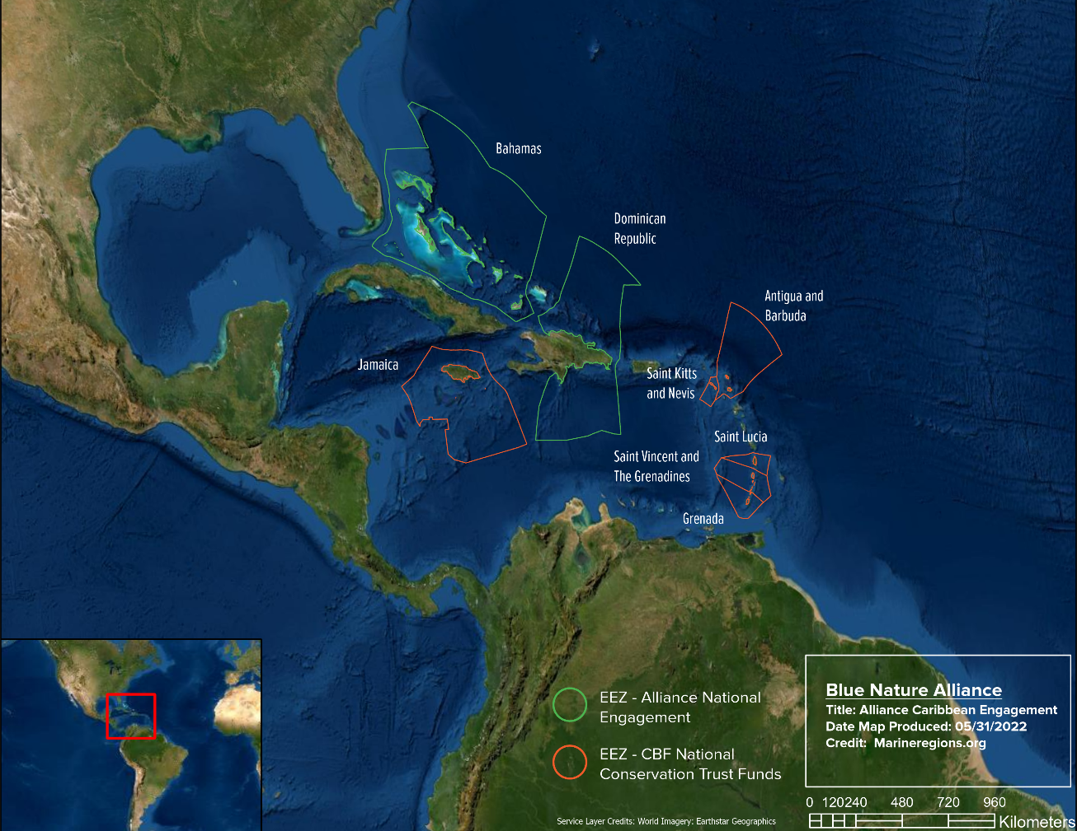

Opportunity & Key Interventions
Partner with the government of Dominican Republic and Fondo MARENA to support the design and implementation of a roadmap to establish new MPAs and foundational management pillars to guarantee effective and lasting ocean conservation.

Alliance Site Lead: Joaquin Labougle
Lead Implementing Partner: Ministry of the Environment and Natural Resources & Fondo MARENA

Success Measures
We will consider new protections when the following have been achieved:

- We will consider an additional ~58,846 km² of ocean conservation areas to be newly designated or expanded upon legal establishment by the government of the Dominican Republic.

We will consider management of ocean conservation areas to be measurably improved when the following have been achieved:

- We will consider 42,000 km² of existing MPAs in the Dominican Republic to be measurably improved upon the adoption of management plans and creation of a surveillance and monitoring strategy.

Description
The wider Caribbean comprises 28 countries and 19 dependent territories, including small island states, coastal states, continental countries, and 3 adjacent large marine ecosystems (LMEs). Twenty-four countries and territories are classified as small island developing states, the largest number of Small Island Developing States within a global LME. Within the wider Caribbean, 15 ecologically or biologically significant areas (EBSAs) have been identified. The marine ecosystem of the wider Caribbean region comprises over 16,000 species and is home to 10% of the world’s coral reefs by area.

The Caribbean has shown sustained political will for ocean conservation through regional-led efforts like the Caribbean Challenge Initiative. Caribbean governments revealed high political interest in aligning with scientific recommendations for more ambitious protected area targets, particularly, in line with upcoming negotiations within the Convention on Biological Diversity (CBD).

Through initiatives like the CCI and CBF, efforts to build in-country capacity have successfully yielded the operationalization of National Conservation Trust Funds (NCTFs) that provide annual grants to appropriate national organizations to support improved MPA management and expansion, among other conservation objectives. Moreover, governments in the region continue to explore opportunities such as debt for nature conversions, blue bonds, MPA access fees, grant financing, and endowment schemes.

There is an opportunity for the Blue Nature Alliance to support the region by deploying technical and financial resources to both: (a) work at a regional level by putting in place regional building blocks to enable increase of MPA coverage and management effectiveness and (b) work at a national level in countries such as the Bahamas and Dominican Republic, which could serve as drivers and models for the regional engagement.

Enhancing New Protections and Effective Management in the Dominican Republic: Currently, the Dominican Republic (DR) has approximately 13% of its jurisdictional waters under protection and the current government has the intention and willingness to increase the national coverage of protection to at least 30%. The government’s plan is to start the process toward 30% by declaring a new large MPA at the marine seamount area known as “Beata Ridge”, in the Caribbean Sea, which could lead to a transboundary marine conservation corridor between Colombia and Dominican Republic. The Alliance will partner with the Ministry of the Environment and Natural Resources and Fondo Marena to design and implement a roadmap aimed at protecting key areas of the jurisdictional waters of the country through the establishment of new MPAs in light of the country’s political interest in attaining 30% of ocean protection and put in place foundational pillars to guarantee effective and lasting management of national large-scale marine protected areas with a focus on management plans, control and surveillance, and sustainable financing.

Projected Timeframe and Funding Envelope

Key Intervention | Jul 2022-Dec 2025
1. Regional Building Blocks | -
2. Bahamas | -
3. Dominican Republic | $ 575,000
Alliance technical input across all interventions | -
Flexible funds to respond to emerging needs (20%) | -
Alliance Funding Envelope | -
In-kind leverage (Skylight, McKinsey) | -
Estimated anticipated leverage (BlueFin Project, PROCARIBBE+, etc) | -
Engagement Total | -

Throughout our engagement, we are committed to helping our local partners and the region to considerably progress towards the effective protection of the 30% of Caribbean waters by promoting the effective and durable management of key areas in order to safeguard some of the most extraordinary marine biodiversity of the region, build climate resilience, and position this unique region as a global model for large-scale and networked ocean conservation.

