**Caribbean Blue Economy Financing Project (BluEFin)**

**Terms of Reference Project Steering Committee**

The **Project Steering Committee (PSC)** will act as the main governing body of the project to guide the Project Coordination Unit (PCU) in the overall execution under the responsibility of the Caribbean Biodiversity Fund (CBF), as per the contract with the United Nations Environment Programme (UNEP), as the implementing agency. It should be noted that the CBF Board of Directors keeps the fiduciary responsibility for the project execution.

1. **Governance Structure under the BluEFin Financing Agreement**

The Financing Agreement between UNEP and CBF governs all operational and administrative matters for the BluEFIn Project. All decisions concerning the BluEFin Project are the sole responsibility of the parties to the Agreement in accordance with clauses of the Financing Agreement (Project: XXXX).

**UNEP**, as the GEF Agency, will act as Implementing Agency (IA) for the project and will be responsible for overall project supervision to ensure consistency with GEF strategies and UNEP policies and procedures, providing guidance on linkages with related UNEP - and GEF-funded activities. It will be responsible for clearance and transmission of financial and progress reports to the GEF. UNEP retains responsibility for review and approval of the substantive and technical reports produced in accordance with the schedule of work.

The **CBF** will serve as the executing agency for the project, in consistency with its mission and current programme of activities. In accordance with UNEP guidelines, the CBF will coordinate the execution of the project providing overall technical oversight to project implementation. The CBF will manage the funds provided to the project by UNEP on behalf of the GEF, in a manner consistent with UNEP financial reporting requirements. In addition, the CBF will be responsible for coordinating the participation of the NCTFs in the five project countries in support of the project.

The project institutional framework and implementation arrangements are illustrated in the figure below.

***Figure 1 – BluEFin project institutional framework and implementation arrangements***

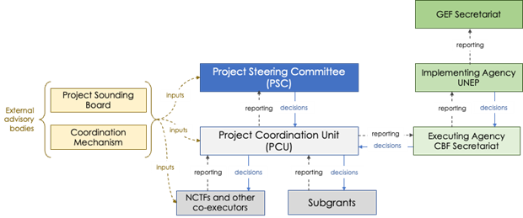

The figure below illustrates the BluEFin project structure within the CBF organisational structure.

***Figure 2 - BluEFin project structure within the CBF organisational structure***

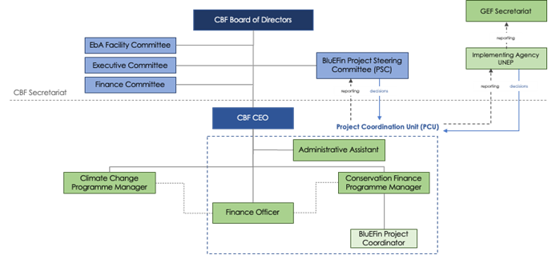

1. **Composition of the Project Steering Committee**

Membership will be confirmed at the inception meeting. The project PSC will capitalise on the structure already in operation for the Caribbean Sustainable Finance Architecture. The CBF and the National Conservation Trust Funds (NCTFs) in the project countries already have agreements and collaboration mechanisms in place and the BluEFin project will take advantage of these existing relationships. The NCTFs include private sector, academia, NGOs and public sector in their Boards, which allows the project to reach out to key audiences in the project countries. In this sense, the PSC will be composed by:

|  |  |
| --- | --- |
| **CBF** | Tanja Lieuw, CF Programme Manager  Karen McDonald Gayle, CEO |
| **UNEP** | A representative of UNEP, as the Implementing Agency |
| **National focal points** | The GEF national focal points from each beneficiary country to nominate one representative and one alternate member to the PSC. Beneficiary countries: Dominican Republic, Grenada, Saint Lucia, St. Vincent and the Grenadines and the Bahamas |
| In case the GEF National focal points decides to appoint a representative from the NCTF, the Conservation Trust Funds are as follows:   1. Fondo MARENA, the National Conservation Trust Fund (NCTF) partner of the CBF in the Dominican Republic since 2016. 2. The Grenada Sustainable Development Trust Fund (GSDTF), the NCTF partner of the CBF in Grenada since 2019. 3. The Saint Lucia National Conservation Fund (SLUNCF), the NCTF partner of the CBF in Saint Lucia since 2019. 4. The St. Vincent and the Grenadines Conservation Fund (SVGCF), the NCTF partner of the CBF in St. Vincent and the Grenadines since 2019. 5. The Bahamas Protected Areas Fund (BPAF), the NCTF partner of the CBF in The Bahamas since 2020.   If the GEF focal point does not appoint the NCTF as his/her representative, the NCTF will be invited toparticipate as observer (no voting rights). |
| **Other Invitees** | One representative of each of the following regional bodies that wish to join[1]: CARICOM (including the Caribbean Development Bank) and OECS. These members will have no voting rights. |
| **Secretariat** | BluEFin Project Leader |

The PSC may invite members of the external advisory bodies (as observers) to their meetings as well as other persons or institutions that it considers appropriate.

1. **Responsibilities of the Project Steering Committee (PSC)**

The PSCwill act as the main governing body of the project to guide the PCU in the overall execution. The PSC will provide strategic guidelines and decision making for the project execution. Its responsibilities will include:

* Provide oversight of project implementation and delivery of the project’s objectives
* Review, amend if appropriate, and approve the draft annual work plan and budget of the project (for subsequent execution by PCU)
* Review and approve annual Project Implementation Reports (PIRs), audit recommendations and external evaluations to insert adaptive management to the project
* Provide input to the mid-term and final evaluations
* Review and approve key decisions, such as the approval of selected projects to receive subgrants within Component 3. The selection will take place by a team of experts which will be decided upon during project implementation.
* Ensure focus of project is kept in-line with project’s goal and objective
* Where necessary, the PSC will support definition of new targets in coordination with, and approval from, the executing partners and UNEP
* Confirm membership, as and if required, of advisory group specialists proposed by the PCU to the PSC

The PCU, primarily the BluEFin Project Coordinator, will act as technical secretariat of the PSC in charge of convening and organising the PSC meetings at an agreed Caribbean location (preferably in one of the five project countries), compiling the minutes of the meeting including action items and recommendations, for matters to be approved, and the monitoring and reporting documents presented by the PCU.

The Project Steering Committee shall operate and take decisions on the basis of consensus, regarding any matter relating to project execution that has implications for core partners. Where full consensus cannot be achieved in reaching agreement during a full meeting of the Committee, on any matter relating to project execution that has implications for core partners, the Secretariat shall, in consultation with the Chairperson, facilitate negotiations during the subsequent inter-sessional period with a view to seeking resolution, and will report the results of these negotiations to the Committee members.

The PSC will provide strategic guidelines and decision making for overall execution. The PSC will establish the execution baselines, consider and approve annual work plans and budgets, as well as annual technical and financial reports and final technical reports. It will also review and approve key decisions. NCTF members coordinate with the governmental institutions in each country to ensure their effective participation in project activities. The 5 NCTFs have appointed directors in the CBF Board. This is a possible overlap that will allow the CBF Board to be constantly informed of the BluEFin project progress and to be accessed if required. It is also a way of promoting that the solutions and the benefits generated by the project are offered to the wider community of NCTFs, supporting regional impact.

1. **Key elements of procedures for the Project Steering Committee**

The following provisional procedure is drafted as a basis for adoption or amendment during the first meeting of the PSC.

* Full members: Full members of the PSC shall consist of representatives of organisations as listed above. Observers and advisors will attend by invitation.
* Representation at meetings: It is the responsibility of the members to find a suitable representative and ensure they are informed of project progress in advance of the meeting.
* Alternate members: In the event that a member representative cannot participate in the meeting, this institution must secure a suitable alternative representative and communicate this choice to the PCU ahead of the meeting. Alternate members in this case will have the same rights as the full members.
* Appointment of members: The GEF Focal Points may appoint someone to represent them in the PSC for specific meetings, if need be. This could be the representative of the beneficiary NCTF of their respective country.
* Amendment of the membership: Notwithstanding the rules contained in this document, the PSC shall have the power to amend, from time to time, its membership, subject to agreement of UNEP-GEF.
* Co-opted members and observers: The PSC may agree, by consensus at the commencement of each meeting to co-opt to any meeting or meetings of the Committee or parts thereof, as the Committee shall deem appropriate.
* Distribution of the agenda: The PCU shall communicate the provisional agenda of each PSC meeting together with all background documentation, to the members at least 2 weeks in advance where possible.
* Background documentation: The background documentation of every PSC meeting should include a report from the Project Coordinator on project activities during the inter-sessional period and a report and recommendations on the proposed annual workplan and budget for the ensuing period.
* Adoption of the Agenda: At the commencement of each PSC meeting, the PSC shall adopt the agenda for the meeting based on the provisional agenda.
* Quorum: A simple majority of the members of the Committee shall constitute a quorum. In case one or multiple members of the PSC cannot attend the meetings in-person, virtual participation can also be accommodated.
* Decision-making: Members will reach agreements by consensus, subject to final approval by UNEP as the IA
* Language: The working language of the PSC will be English. All documents will primarily be available in English. Simultaneous translations will be provided during meetings to PSC members who do not speak and/or understand English fluently.

1. **Frequency of meetings**

A Chairperson will be appointed in the first PSC meeting, the Inception Meeting. UNEP will open the meeting and invite the members of the PSC to identify the Chair and agree on the mechanism for selecting future PSC Chairs. During the Inception meeting the draft ToRs will be reviewed, amended (if required) and agreed.

The PSC will meet face-to-face once every year and virtually whenever deemed necessary. The PSC Chairperson, upon recommendation of the PCU, will have the discretion to call additional meetings if necessary. The PSC may invite members of the external advisory bodies (as observers) to their meetings as well as other persons or institutions that it considers appropriate.

The PSC will meet once a year; in case urgent matters need to be addressed, online meetings can be scheduled.

1. **Secretariat**

The Project Coordination Unit for the BluEFin project, led by the BluEFin Project Leader, shall prepare and provide at least 10 working days in advance to the PSC meeting along with appropriate briefing materials, including:

• Agenda for the meeting

• Notes/Actions from previous meeting

• Last progress report of the Project

• Any other document or information deemed relevant for the meeting.

The BluEFin Project Leader shall be responsible for the preparation of progress reports and other technical project related documents for review and preparing minutes of the meeting.

1. **Conflict of Interest**

Where there is a conflict of interest, the PSC Member so affected shall declare his/her interest to the group and the details of the conflict are to be recorded by the Secretary. The PSC Member who has a conflict of interest shall not participate in the deliberations on the particular matter and will excuse himself/herself from the discussions in respect of those interests during the period of discussion of the matter.

1. **Confidentiality of Information**

As may be relevant, some information received by the PSC may be confidential and cannot be disclosed to parties outside of the Group without prior approval of the CBF CEO.

1. The representatives of the regional bodies will join depending on their availability and willingness to participate.